Name | Arsh Raina
UID no. | 2021600053
Experiment No. | 6

AIM: | Demonstrate the use of two-dimensional arrays to solve a given problem.
Program 1
PROBLEM STATEMENT : | // Write a program to perform Matrix Addition, Subtraction, Multiplication, Transpose of Matrix and Frobenius Norm of Matrix. Dimensions of matrices will be decided by the user.
PROGRAM: | #include <stdio.h>  #include <math.h>  #define pf printf  #define sf scanf  int row, col;  void printM(int m[row][col]);  void add(int m1[row][col], int m2[row][col]);  void sub(int m1[row][col], int m2[row][col]);  void mul(int m1[row][col], int m2[row][col]);  void trans(int m1[row][col], int m2[row][col]);  void norm(int m1[row][col], int m2[row][col]);  int main() {  int choice;  pf("Enter the rows and colums seprated by a comma: ");  sf("%d,%d", &row, &col);  int m1[row][col];  int m2[row][col];  for(int i = 0; i< row; i++) {  for(int j = 0;j < col;j++) {  pf("Enter value for m1[%d][%d]:", i, j);  scanf("%d", &m1[i][j]);  }  }  for(int i = 0; i < row; i++) {  for(int j = 0; j < col; j++) {  pf("Enter value for m2[%d][%d]:", i, j);  scanf("%d", &m2[i][j]);  }  }  pf("Matrix 1:\n");  printM(m1);  pf("Matrix 2:\n");  printM(m2);  pf("1 Addition\n2 Subtraction\n3 Multiplication\n4 Transpose\n5 Norm\n");  pf("\n");  pf("What operation do want to perform?\n");  sf("%d", &choice);  if (choice == 1) {  add(m1,m2);  }  else if (choice == 2) {  sub(m1,m2);  }  else if (choice == 3) {  mul(m1,m2);  }  else if (choice == 4) {  trans(m1,m2);  }  else if (choice == 5) {  norm(m1,m2);  }  return 0;  }  void add(int m1[row][col], int m2 [row][col]) {  pf("\n");  int m3[row][col];  for(int i = 0; i< row; i++) {  for(int j = 0; j < col; j++) {  m3[i][j] = m1[i][j] + m2[i][j];  }  }  printM(m3);  pf("\n");  }  void sub(int m1[row][col], int m2 [row][col]) {  pf("\n");  int m3[row][col];  for(int i = 0; i< row; i++) {  for(int j = 0; j < col; j++) {  m3[i][j] = m1[i][j] - m2[i][j];  }  }  printM(m3);  pf("\n");  }  void mul(int m1[row][col], int m2[row][col]) {  int m3[row][col], sum = 0;  if (row == col) {  for(int i = 0; i< row; i++) {  for(int j = 0; j < col; j++) {  for(int k = 0; k < row; k++) {  sum += m1[i][k] * m2[k][j];  }  m3[i][j] = sum;  sum = 0;  }  }  printM(m3);  }  else {  pf("Multiplication not possible!");  }  }  void trans(int m1[row][col], int m2[row][col]) {  int m3[row][col];  int m4[row][col];  for(int i = 0; i< row; i++) {  for(int j = 0; j < col; j++) {  m3[j][i] = m1[i][j];  m4[j][i] = m2[i][j];  }  }  pf("Transpose of Matrix 1\n");  printM(m3);  pf("\n");  pf("Transpose of Matrix 2\n");  printM(m4);  }  void norm(int m1[row][col], int m2[row][col]) {  float s1 = 0;  float s2 = 0;  for(int i = 0; i< row; i++) {  for(int j = 0; j < col; j++) {  s1 += (m1[i][j])*(m1[i][j]);  s2 += (m2[i][j])*(m2[i][j]);  }  }  float n1 = sqrt(s1);  float n2 = sqrt(s2);  pf("Norm of Matrix 1\n");  pf("%f", n1);  pf("\n");  pf("Norm of Matrix 2\n");  pf("%f\n", n2);  }  void printM(int m[row][col]) {  for(int i = 0; i < row; i++) {  for(int j = 0; j < col; j++) {  pf("%d ", m[i][j]);  if(j == col-1){  pf("\n");  }  }  }  pf("\n");  }
RESULT:
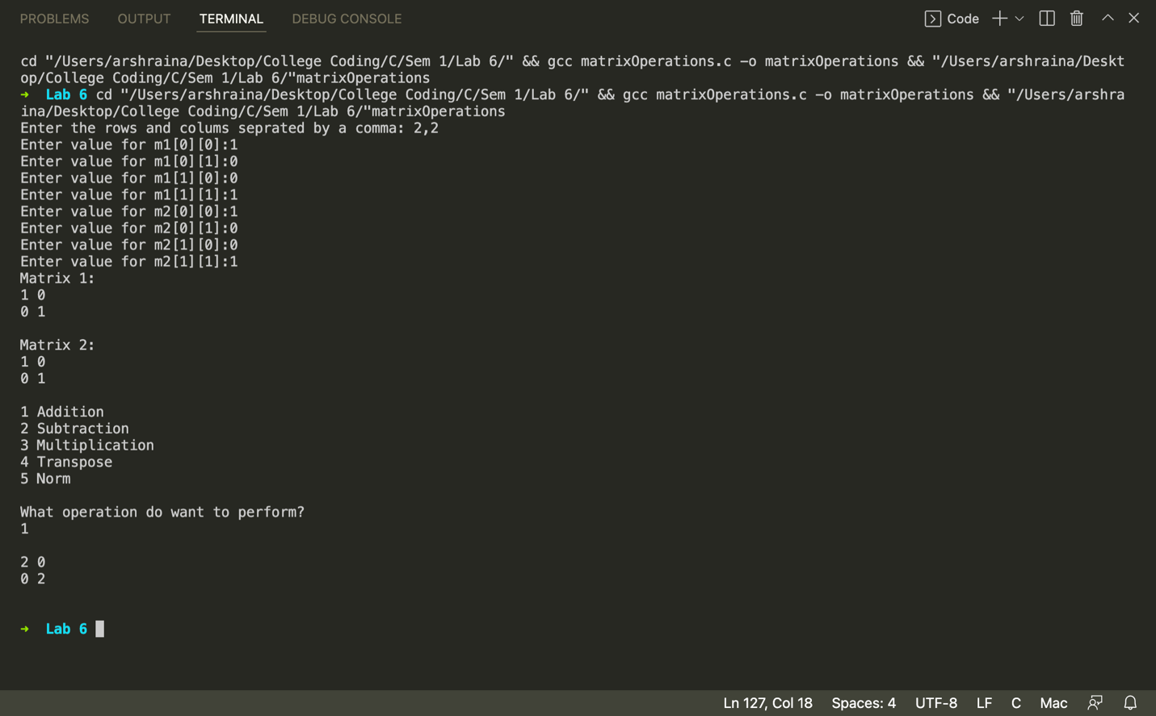
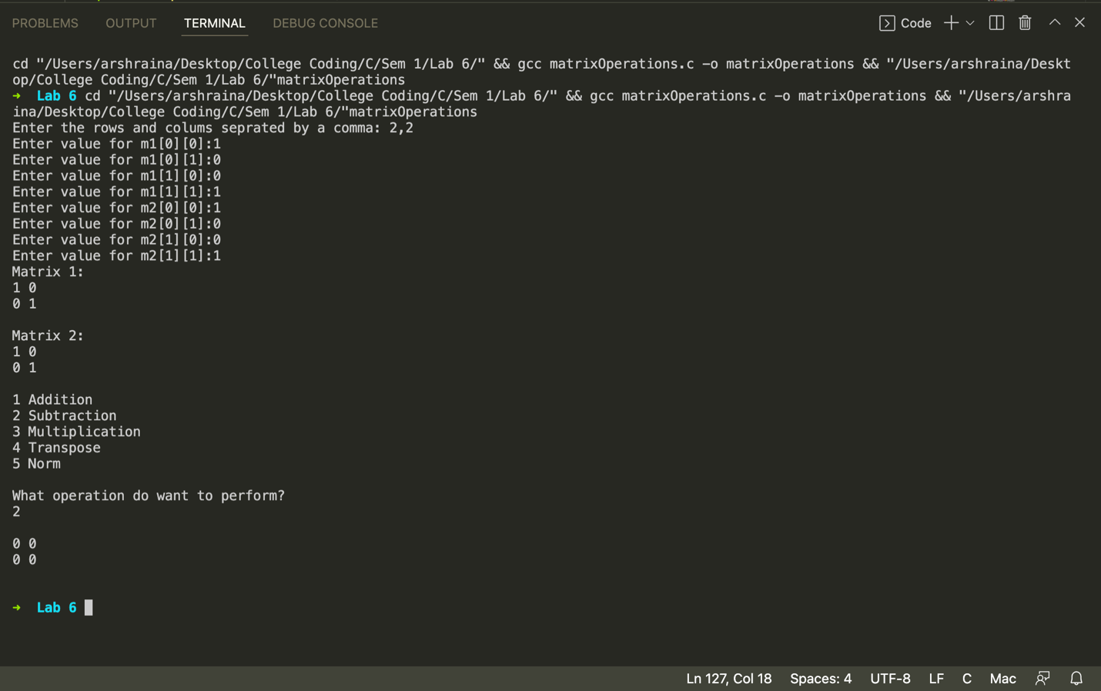
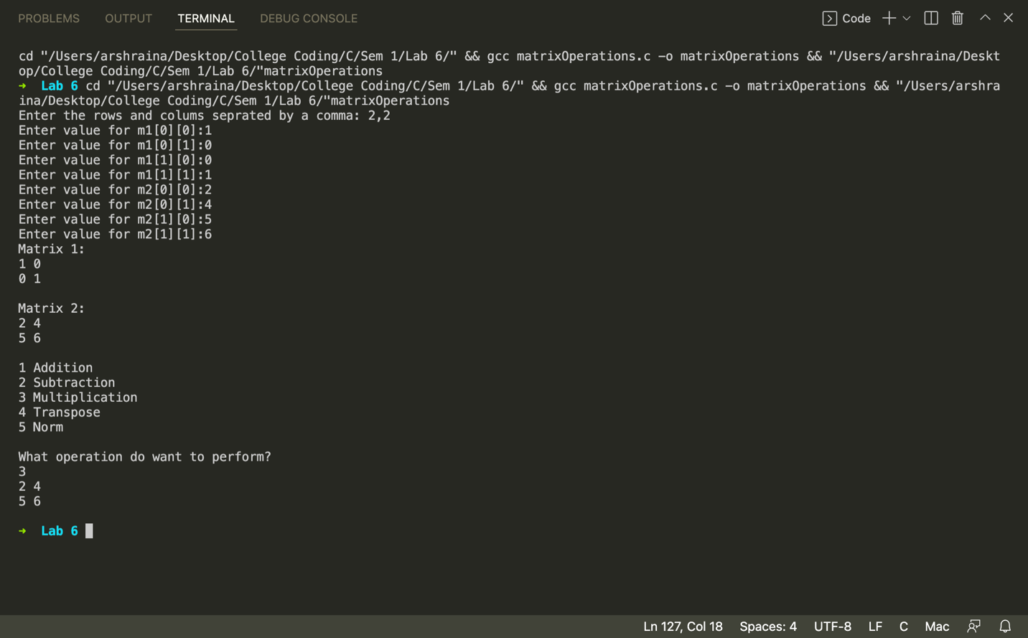
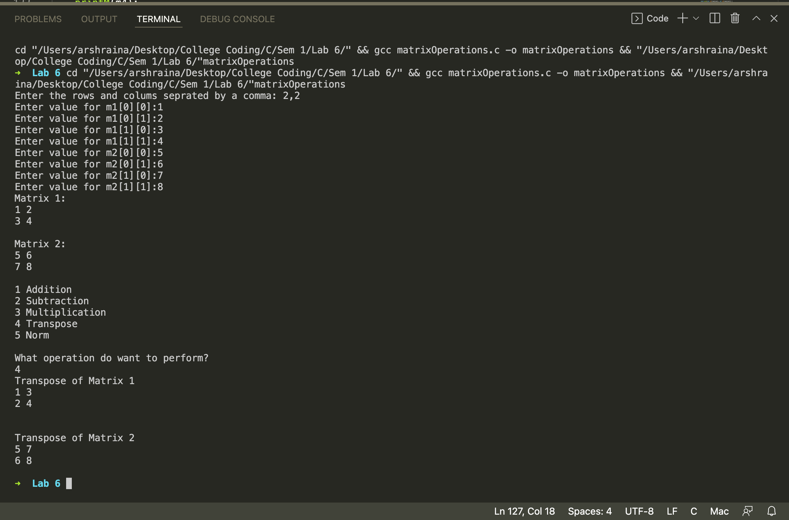
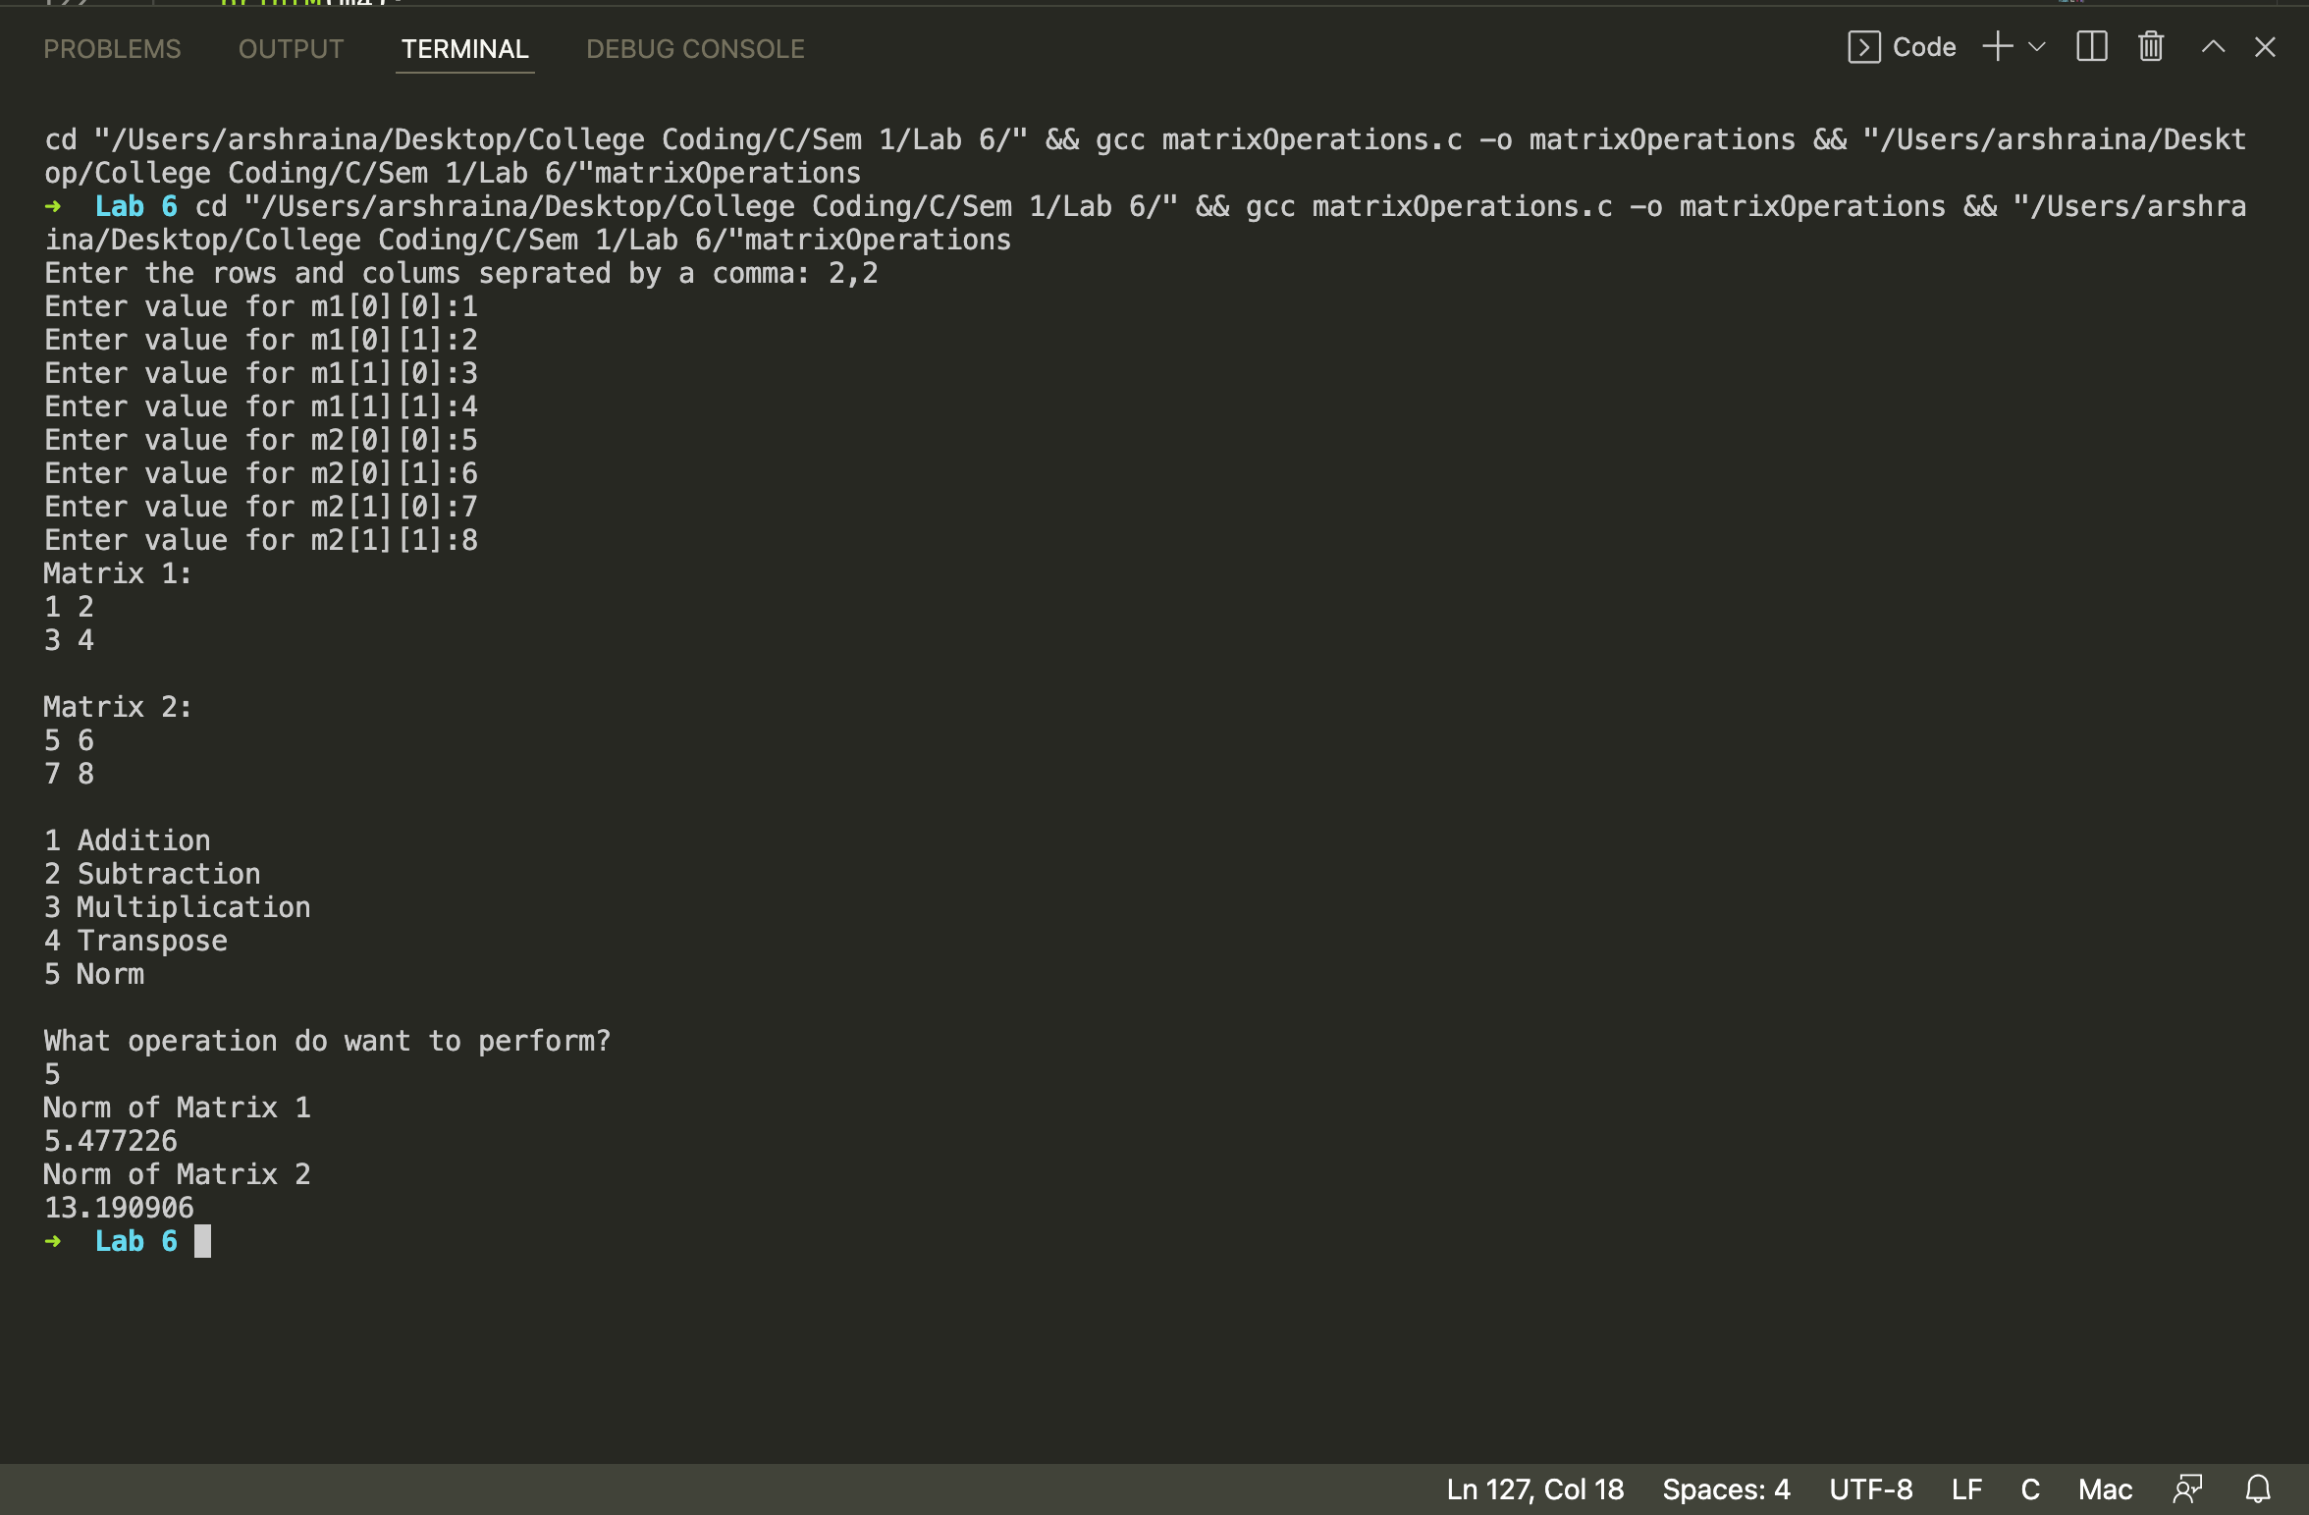
Program 2
PROBLEM STATEMENT : | // Write a program which reads the current year followed by N followed by a list of N employee numbers and their current ages. Produce a list showing the years in which the employees retire (become 65 years old). If more than one employee retires in a given year then include them all under the same heading.
PROGRAM: | #include <stdio.h>  int main() {  int n, cYear;  printf("Number of employees: ");  scanf("%d",&n);  printf("Current year: ");  scanf("%d", &cYear);  int arr [n][2];  for (int i = 0; i < n; i++) {  printf("Enter employee ID and age separated by comma: ");  scanf("%d,%d", &arr[i][0], &arr[i][1]);  }  int min, pos = 0, temp = 0;  for(int i = 0; i<n; i++)//Loop to sort the Matrix based on year  {  min = arr[i][1];  for(int j = i; j<n; j++)//Loop to calculate next min value  {  if(arr[j][1]<=min)  {  min = arr[j][1];  pos = j;  }  }  //Swap(arr, k, pos);2  for(int k = 0; k<2;k++)//Loop to swap Variables  {  temp = arr[i][k];  arr[i][k] = arr[pos][k];  arr[pos][k] = temp;  }  }  int count = 0;  for (int i = 0; i < n; i++) {  if (count == 0) {  count = arr[i][1];  printf("Year of retirement: %d \n", cYear + 65 - arr[i][1]);  printf("Employees %d ", arr[i][0]);  }  else if (count == arr[i][1]) {  printf("%d", arr[i][0]);  }  else {  count = arr[i][1];  printf("\nYear of retirement: %d \n", cYear + 65 - count);  printf("Employees: %d", arr[i][0]);  }  }  }
RESULT:
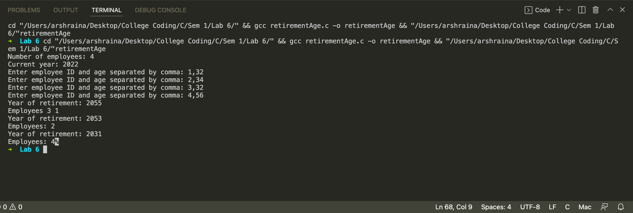
Program 3
PROBLEM STATEMENT: | // A matrix is singular if and only if its determinant is 0. Write a function which determines whether a matrix is singular or not. keep max size4 x 4
PROGRAM: | #include <stdio.h>  #define pf printf  #define sf scanf  int Det(int A[4][4], int n);  void print(int A[4][4], int n);  void main() {  int n, A[4][4], det;  pf("Enter order N of NxN Matrix.\n");  sf("%d", &n);  pf("Enter the Matrix.\n");  for(int i = 0; i<n; i++) {  for(int j = 0; j<n; j++) {  pf("Enter A[%d][%d]: ",i,j);  sf("%d", &A[i][j]);  }  }  print(A, n);  det = Det(A, n);  pf("\n%d\n", det);  if ( det == 0) {  pf("Singular Matrix\n");  }  else {  pf("Not Singular Matrix\n");  }  }  void print(int A[4][4], int n) {  pf("\n");  for(int i = 0; i<n; i++) {  for(int j = 0; j<n; j++) {  pf("%d ",A[i][j]);  }  pf("\n");  }  }  int Det(int A[4][4], int n) {  int det, sub[4][4], sign, sum = 0;  if(n == 1) {  sum = A[0][0];  }  else if(n == 2) {  sum = (A[0][0] * A[1][1]) - (A[1][0] * A[0][1]);  }  else {  for(int o = 0; o<n; o++) {  sign = (o%2==0)?1:-1;  for(int p = 0, a = 1; p<n-1; p++, a++) {  for(int q = 0, b = 0; q<n-1; q++, b++) {  if(q == o){  b++;  }  sub[p][q] = A[a][b];  }  }  det = Det(sub, n-1);  sum+= A[0][o] * sign * det;  }  }  return sum;  }
RESULT:
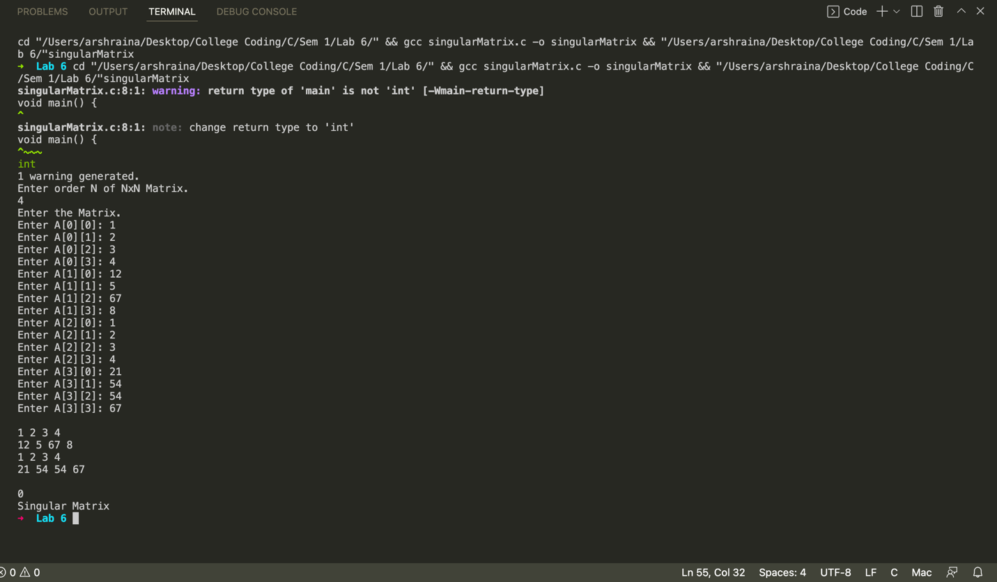
CONCLUSION: | Successfully used the concept of 2D arrays to solve the given problems.

